NEW ARRIVAL CARE PACKS
New residents to recovery houses, re-entry transitional houses and homeless shelters often arrive with nothing. It means so much to them to receive a welcome pack filled with items they will need as they begin their new lives.
The items can be mini size to fit into purses or full size and go into backpacks or laundry baskets. The container. can be gently used or new. Hygiene products should be new, but brand does not matter.
Food/Drink
- Mints/gum/hard candies
- Reusable water bottle
- Individually wrapped snacks
- Single packs of drink mix
- High protein snack packs (nuts, granola, trail mix, Jerky, etc)
Clothing Accessories
- Sunglasses
- Socks
- Gloves/hats/scarves
- Underwear
- Wallet
- Key chain lanyards
Cleaning Supplies & Household Items:
- Clorox wipes
- Lysol spray
- Windex
- Paper towels
- Bathroom cleaners
- Dish soap
- Dish scrubbies
- Hand soap
- Laundry detergent
- Dryer sheets
- Stain spray
- Toilet paper
- Tissues
- First Aid Supplies

Health/Hygiene products:
- Toothbrush/Toothpaste
- Floss
- Mouthwash (alcohol free)
- Chapstick
- Hand lotion
- Body spray
- Dry shampoo
- Deodorant
- Individually wrapped wipes
- Tissue packs
- Tylenol/Advil
- Eye drops
- First aid kit/Band aids
- Emergen-C / vitamins
- Cough drops
- Rolls of Tums
- Brush, combs
- Hair ties
- Compact mirror
- Feminine Hygiene Products (tampons/pads)
- Hand sanitizer
- Shampoo, Conditioner or 2-in-1, 3-in-1
- Body Wash, Soaps, face wash
- Nail clippers, Emory board
- Tweezers
- Grooming kit
- Q-tips/cotton rounds
- Disposable razors/shaving cream
Container: Large purse, messenger bag, tote bag, full size or drawstring backpack, personal laundry basket
Extras
- Personalized notes of encouragement
- Gas cards
- Grocery store gift cards
- Stamps
- Prepaid phone cards

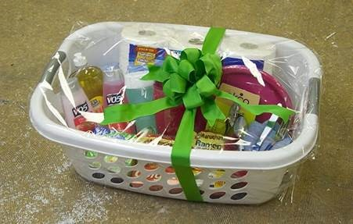
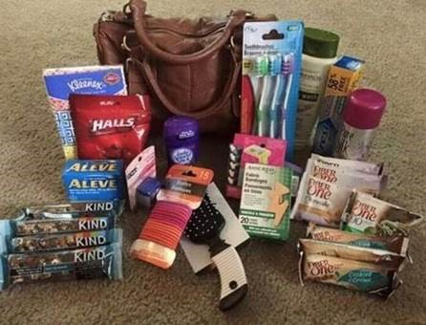
How to Donate:

